|  |  |  |  |  |
| --- | --- | --- | --- | --- |
| C:\Users\jmcki\AppData\Local\Microsoft\Windows\INetCache\Content.Word\12119116_10153093924715986_7643511064430065184_n.png |  | |  | | --- | |  | | Campus Ministers Serving alongside our Campus Pastor |   Faith, Prayer, Worship & Community |
|  |  |  |
| THE MSC IN ACTION on CAMPUS & AROUND THE COMMUNITY |  | CAMPUS & COMMUNITY ENGAGEMENT |

“Telling our story” as a campus ministry is an important part of what we do throughout the semester. It’s wonderfulwhen we get to take students to see and meet the people who support and pray for this ministry. So far this year we’ve *already* had the privilege to share our story with members of the Carlisle UMC, South Shore UMC, Shiloh UMC in Fleming Co., KY and Mt. Sterling UMC. On the evening of October 29th we will have the opportunity to lead worship at the Greenup UMC with our own Bishop Fairley in attendance! We are **thankful** for every chance we get to share what God is doing at the MSC.

Looking Forward

As we look forward into the rest of the semester we’ve got some events we want to “highlight.” MSU Homecoming is just around the corner, October 20-21st, and the MSC will be excited to open its doors once again to Alumni coming back for a visit! Our annual Campus-wide Thanksgiving Dinner is on the books for November 9th. We feed LOTS of hungry college students and get a chance to share the love of Jesus with them. Chi Omega “Follies”, November 14th, is a way to let people know about our campus ministry. Please continue to pray and lift up our students and Pastor Drew as we continue through the semester. Blessings!

We’re Off to a Good Start!

The MSU Wesley Foundation (aka “Methodist Student Center” or “MSC”) is welcoming all sorts of new people with the start of a new year. With our opening weekend post-church MSC Cookout and “Open House,” we’ve met *many* new students wanting to get involved with a campus ministry. Our seats continue to be filled at our Monday night service, Devos, as well as our newer Wednesday night service, Alpha Omega, and SMASH (our weekly Bible Study) on Thursday nights. 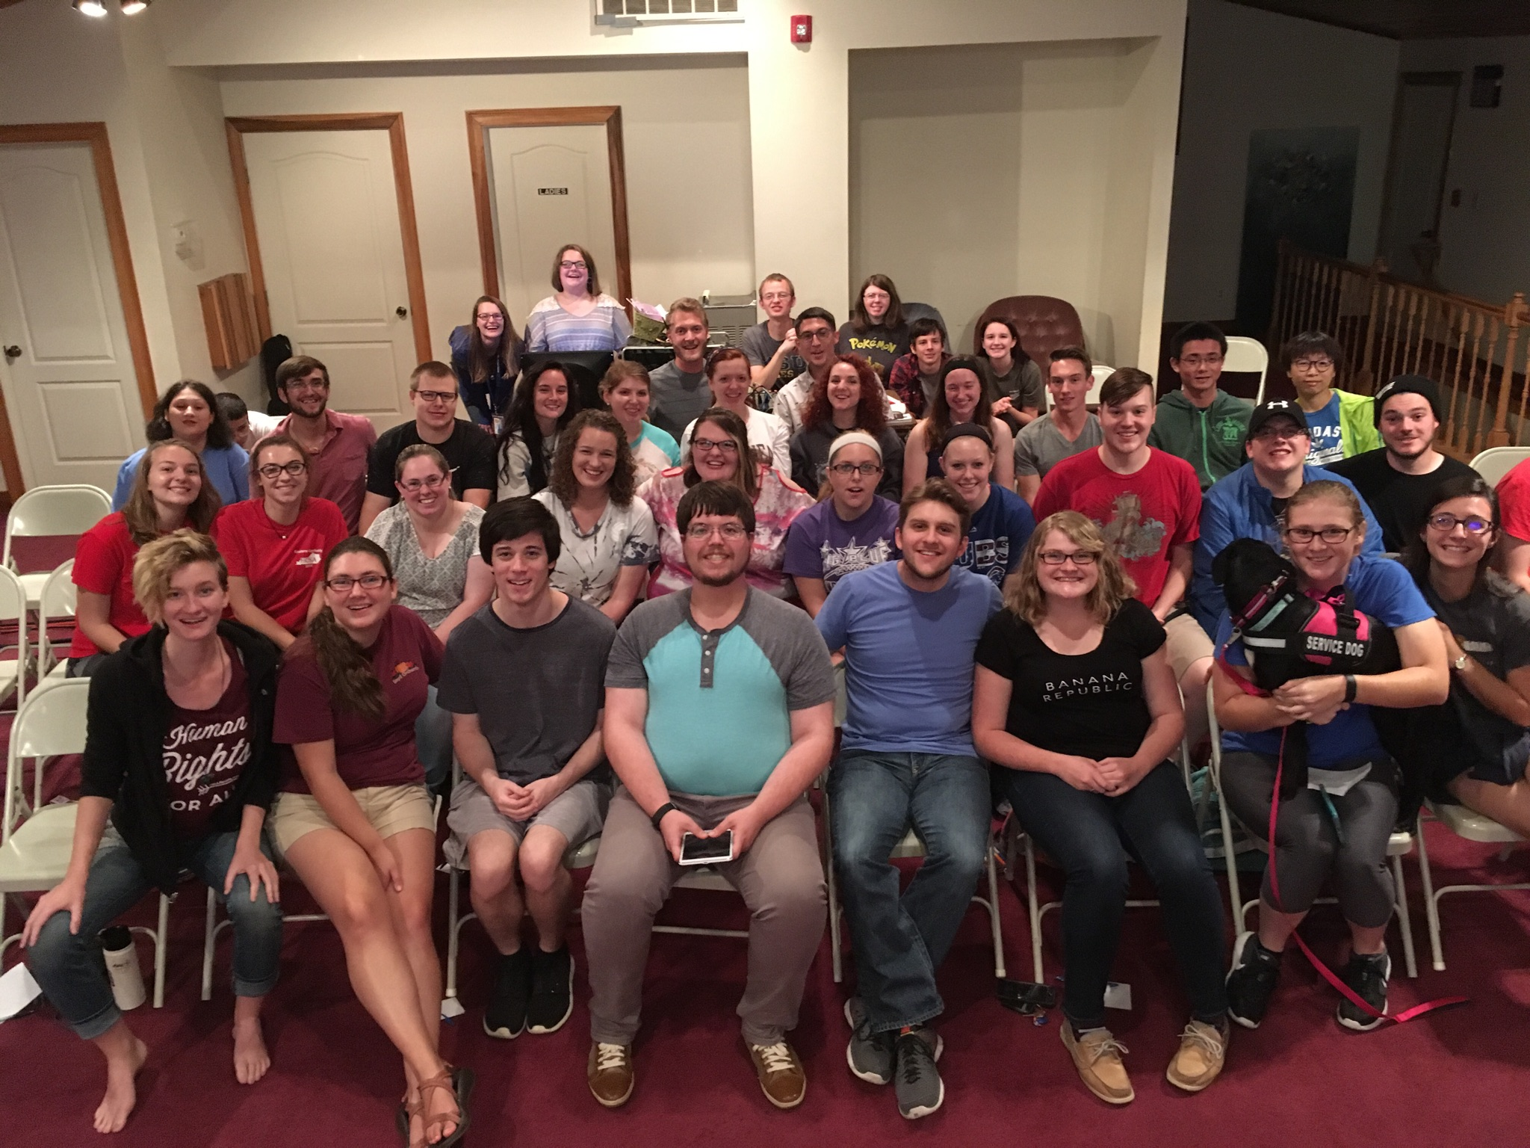

We are also adding a T.G.I.F. (Thank God It’s Friday Food and Fellowship) on Friday nights to play games and just fellowship for anyone wanting something to do on the weekend! The MSC has also become host to a community prayer meeting once a month, where we’ve made connections to pray for our ministry as well as the Morehead community.

Lakes, Festivals, and Sunday Outings! Oh My!



This year instead of taking our usual Fall retreat, we packed up the van and lots of cars full of students, and headed for Park Lake in Fleming county! Our evening was filled with grilled burgers and hot dogs, volleyball, dips in the lake, smores, and a night of worship under the stars. This was a fun weekend event for students to “get off the island” of campus and enjoy some time out in nature!

The MSC also had the opportunity to reach out to the community at Morehead’s annual Arts and Eats Festival. We partnered with the Morehead United Methodist Church to serve food and tell people about Jesus and about what we do (& when we do it) both at the MSC and at the local Church!