|  |  |  |  |  |
| --- | --- | --- | --- | --- |
| C:\Users\jmcki\AppData\Local\Microsoft\Windows\INetCache\Content.Word\12119116_10153093924715986_7643511064430065184_n.png |  | |  | | --- | | Faith, Prayer, Worship & Community | | Campus Ministers Serving alongside our Campus Pastor | |
|  |  |  |
| THE MSC IN ACTION on CAMPUS & AROUND THE COMMUNITY |  | CAMPUS & COMMUNITY ENGAGEMENT |

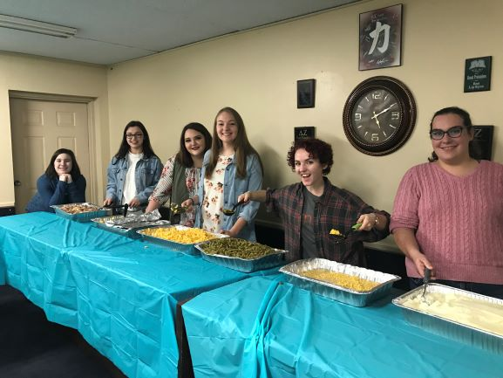

Faculty and Staff Night

November 19th was a special night at the MSC. Students asked some of their professors to attend our Monday night DEVOS service to share a word of witness. Dr. David Peyton (Professor of Biology) KILLED IT on the bass as we started our evening out with songs of praise. Mary Suzanne White followed with a wonderful message about how God has given her everything she has needed to survive this long and how she knows the Lord has a plan for all of us, even if it goes against our own plan. Thank you both so much for your time and your support of our ministry!

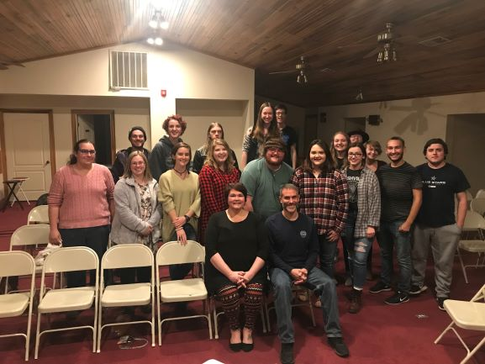

Follies in Full Swing

Every fall semester the sorority Chi Omega puts on a philanthropy event called Follies, benefiting the Make-A-Wish Foundation. The students at the MSC created and perfected a “Marvel Superhero” themed dance routine to add to the show. We are very proud of the dedication and hard work these students put into their routine!

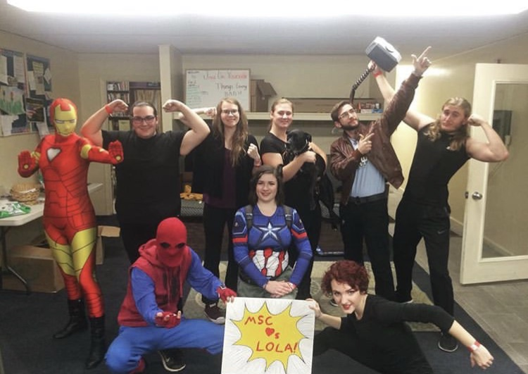

The Annual MSC Thanksgiving Dinner

Every year the Methodist Student Center holds a Thanksgiving meal for the public. Students work hours and hours in the kitchen to prepare enough food. This year we served over 200 plates and even had some left over! We hope that through this meal we can spread the light of Christ on campus and hopefully allow more people to feel like they belong at the MSC. We want everyone to feel welcome here!

The Crossing Comes to Visit MSU!

For the first time since 2014, our Irish/Celtic musician friends, The Crossing, came to Morehead again! From October 3rd-5th they were able to minister through their music to over 200 people! We are so grateful they were able to come and visit again!

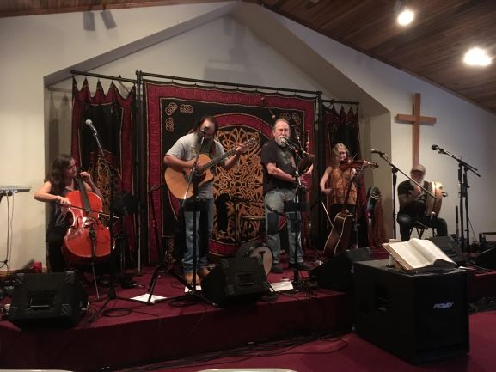

The KYUMC’S Methodist Ladies

The students at the MSC were graciously given a free dinner from Fazoli’s near the end of October, provided by the KYUMC’s United Methodist Women! Not only did these women provide dinner for over 80 people, but they blessed us with an abundance of gift cards to a variety of places in Morehead! We were able to put these gift cards to good use with our Thanksgiving Dinner being right around the corner. A huge “Thank You” goes out to the KYUMC’s United Methodist Women. Your kindness was such a blessing for our community.

telling many known stories about the titles certain people have obtained over the years, while inviting us to think of our own titles whether they be “good” or “bad”. Although some of these titles are things we would like to ignore, we are able to give them up to God to become more like Him. THANK YOU, Mrs. Freire, for your powerful message!

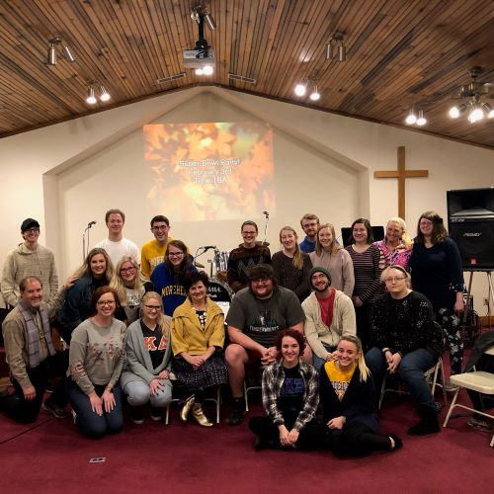

Superbowl Party

Our annual “three tier” Superbowl Party was a blast this year. Starting at 6:00 p.m. on Superbowl Sunday students were welcomed to gather at the MSC no matter what the game meant to them. On the top floor we had a space for the “super fans”; on the middle floor students who mostly wanted to watch the commercials gathered for fellowship and laughter; and students who had no interest in football what-so-ever went to the basement to play games and hang out. The food was delicious, and we all had a fantastic time!

Dr. Jay Morgan Visits the MSC

Morehead State University’s President came to share at our Wednesday night Alpha Omega gathering on February 6th. Dr. Jay Morgan encouraged us to grow, not only in our faith, but in relationships with others, as life-long learners, and with a healthy lifestyle (see Luke 2:52). As always, it is a pleasure to have President Morgan speak at the MSC!

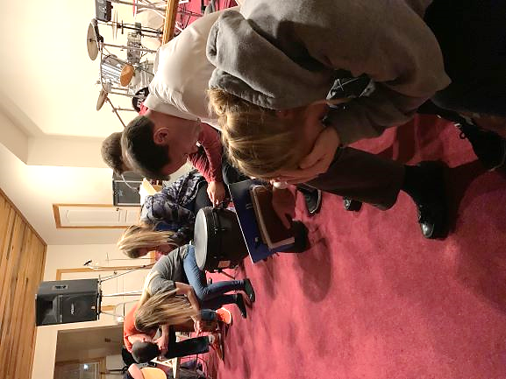

Christianity and Science

Dr. Kent Price from the Physics Department at MSU came to share a word of witness with our students THREE WEEKS IN A ROW!!! His sermon series “Christianity and Science” was a huge hit at our weekly Thursday night S.M.A.S.H. gatherings at the beginning of February this semester. He explained how he lives life each day as a scientist AND a believer. We are very thankful to have faculty that want to share their testimonies with us.

Fall 2018 Graduates

On December 8th, 2018, Morehead State University held its Fall Commencement. We pray that every new alumnus is lead on the path God has made for them, but we would especially like to pray for and thank these students for the time and commitment they have given to the Methodist Student Center over the years: Lindsey Anderson (who graduated with her master’s degree), Max Bailey (pictured right), Elaine White Coleman, Andrew Hall, Kristen Royse, and Nicki Weber (pictured left). We hope you all continue to carry the light of Christ with you through this new chapter of your life!

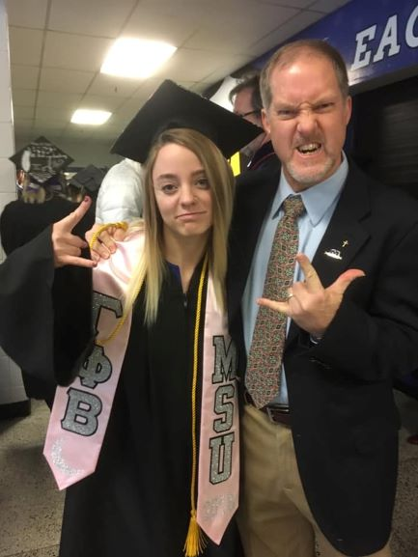 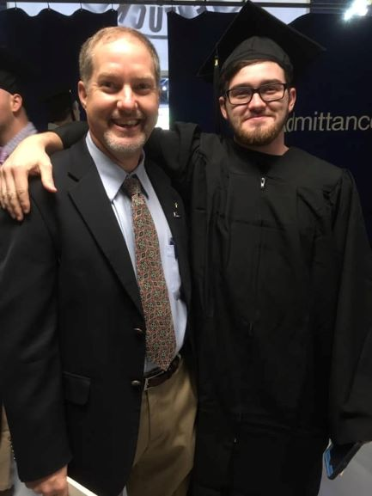

Laura Freire Kicks Off the Semester!

On Wednesday, January 16th, 2019 we had Kappa Delta sorority alum, Laura Freire as our guest speaker at our first Alpha Omega gathering of the semester! She began the evening by