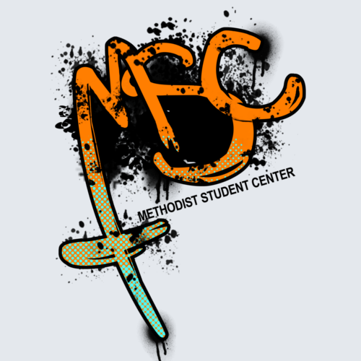 |  | Campus Ministers Serving alongside our Campus Pastor  Faith, Prayer, Worship & Community
THE MSC IN ACTION on CAMPUS & AROUND THE COMMUNITY |  | CAMPUS & COMMUNITY ENGAGEMENT
There’s a light at the end of the tunnel!
Towards the end of the semester students are drained of energy and are just ready for the semester to be over. At the MSC we try to help the students stay focused by providing what every student needs to keep going: FOOD! During the last week of school, the MSC tries to provide an evening meal every night. This is a great opportunity to bring people through our doors because what starving college student doesn’t love FREE FOOD? Monday night, we were provided food by a Sunday school class from the Morehead Methodist Church, and Tuesday night Pastor Drew invited a bunch of rowdy college students to his house for a Finals Fiesta!
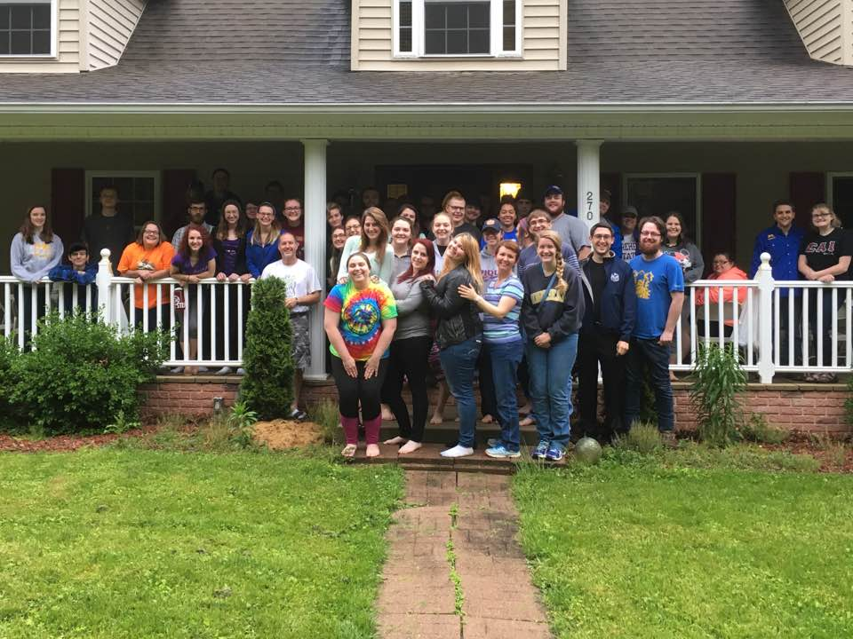
Wednesday we had our meal at the Methodist church and Thursday we were provided a meal by Pastor Aaron Mansfield!

Let it Glow, Let it Glow!

The MSU Wesley Foundation (aka “Methodist Student Center” or “MSC”) was surrounded by people at one of our most recent annual events, the Glow in the Dark Easter Egg Hunt! College students and families from the community alike came to participate in finding over 2,000 Easter eggs hidden across campus. The MSC was packed with people eager to find several prizes that were hidden with some of the eggs. It was a great time for the students to invite friends and meet new people. Throughout the night around 80 new students and community members came to participate!

Faculty/ Staff Night!

Every year we have a post-Easter Devos service that is hosted by none other than our very own faculty and staff from the University! It’s an exciting time to see the professors in a different light, teaching us about the most important subject: Jesus! Several staff led worship and a few of them gave us part of their testimonies. It was truly a wonderful night with faculty showing us how to be great representatives of Jesus throughout every part of life. We are thankful for all the faculty and staff that are representing Christ on our campus and ask that you continue to pray for them as well as our ministry!
Last Alpha Omega
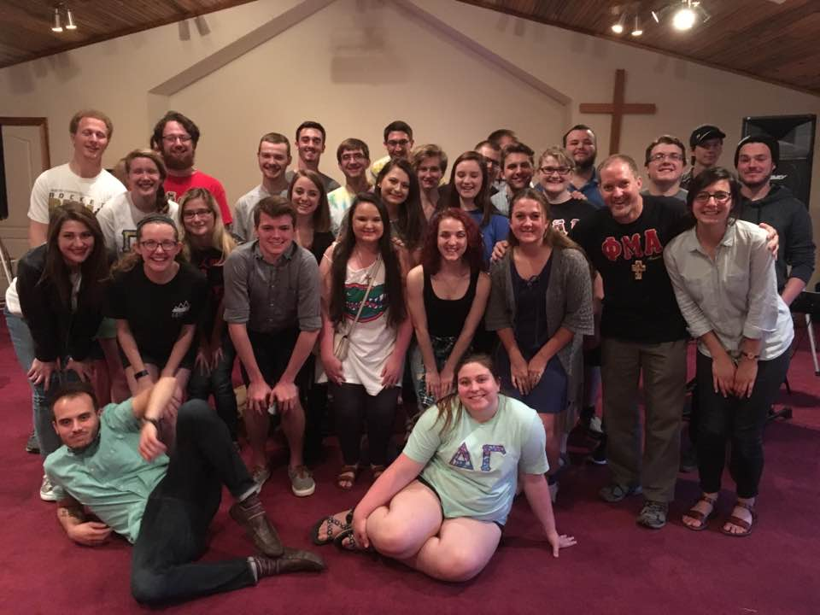
Our last Alpha Omega we got to celebrate all that this ministry has become and all the people that it has touched throughout the year. We said goodbye to several seniors who were graduating and got to pray over everyone that is leaving and starting out elsewhere. Please continue to pray for this ministry and for those it touches on Wednesday nights!
Graduation and Commissions
At the end of the semester we got to see 18 seniors actively involved with the MSC graduate. We also had the pleasure of commissioning two of them into the Kentucky Annual Conference as they begin serving as United Methodist pastors (glory to God!) Please continue to pray for these students as they begin the journey after college!

This summer we also have the pleasure of hosting an Isaiah Project intern who will be here helping Pastor Drew. Nick Hites (Prestonsburg, KY) is one of the MSC’s very own looking to pursue a life in ministry. You will hear from Nick in an MSC Newsletter later this summer
Thank you to all who generously support the MSC and ministry we have on Morehead State’s Campus!
Please continue to lift up Pastor Drew and his family in your prayers as they continue to lead this ministry with the Holy Spirits help.
Blessing to all of you in the name of our Lord and Savior, Jesus Christ!

